MEAD QUILTERS’ NEWSLETTER APRIL 2023.

Hello Everybody,

The time for another newsletter has come round again!

In March we had our first speaker of the year. Penny Bicknell travelled from Chichester bringing with her a very varied selection of interesting and original quilts. Her theme was “Across the Generation Gap” and she talked to us about how, unusually, she taught her mother to quilt ( it was the other way round with me) and how her mother went on to produce a large number of often very large quilts in vibrant colours and all by hand. Angels featured in many of the quilts and embellishments such as beads were often added.

Penny and her mother made many quilts together and now Penny works on her own producing and exhibiting items from large bed quilts to small panels
http://www.pennyquilts.co.uk/index.htm

Dates for your Diary

4th April. 9.30am Morning meeting.

If you are taking part in the Disappearing 9 patch scrappy challenge please will you bring your 52 five and a half inch blocks with you ready for the big swap.

18th April 7.30pm This will be a sewing evening.

Bring a project to work on and an item for Show and Tell.

2nd May 9.30 am Morning meeting

16th May 7.30pm Our speaker will be Anne Kelly

https://annekellytextiles.com/

14th October Mead Quilters’ Show

Let’s have lots of colourful cushions for the raffle.

Other Events

15 April Northants Area Day in Yelvertoft
The speakers will be Sarah Hibbert and Kim Porter

Contact
reg7@quiltersguild.org.uk if you wish to attend.

5th - 8th May Living Crafts at Hatfield House

13th May Mimram Quilters Exhibition at Datchworth Village Hall

https://mimramquilters.com/

Until 18th June. Royal Academy exhibition “Souls Grown Deep like the Rivers” . Work of Black artists of the American south including quilts of Gees Bend.

https://www.royalacademy.org.uk/exhibition/souls-grown-deep
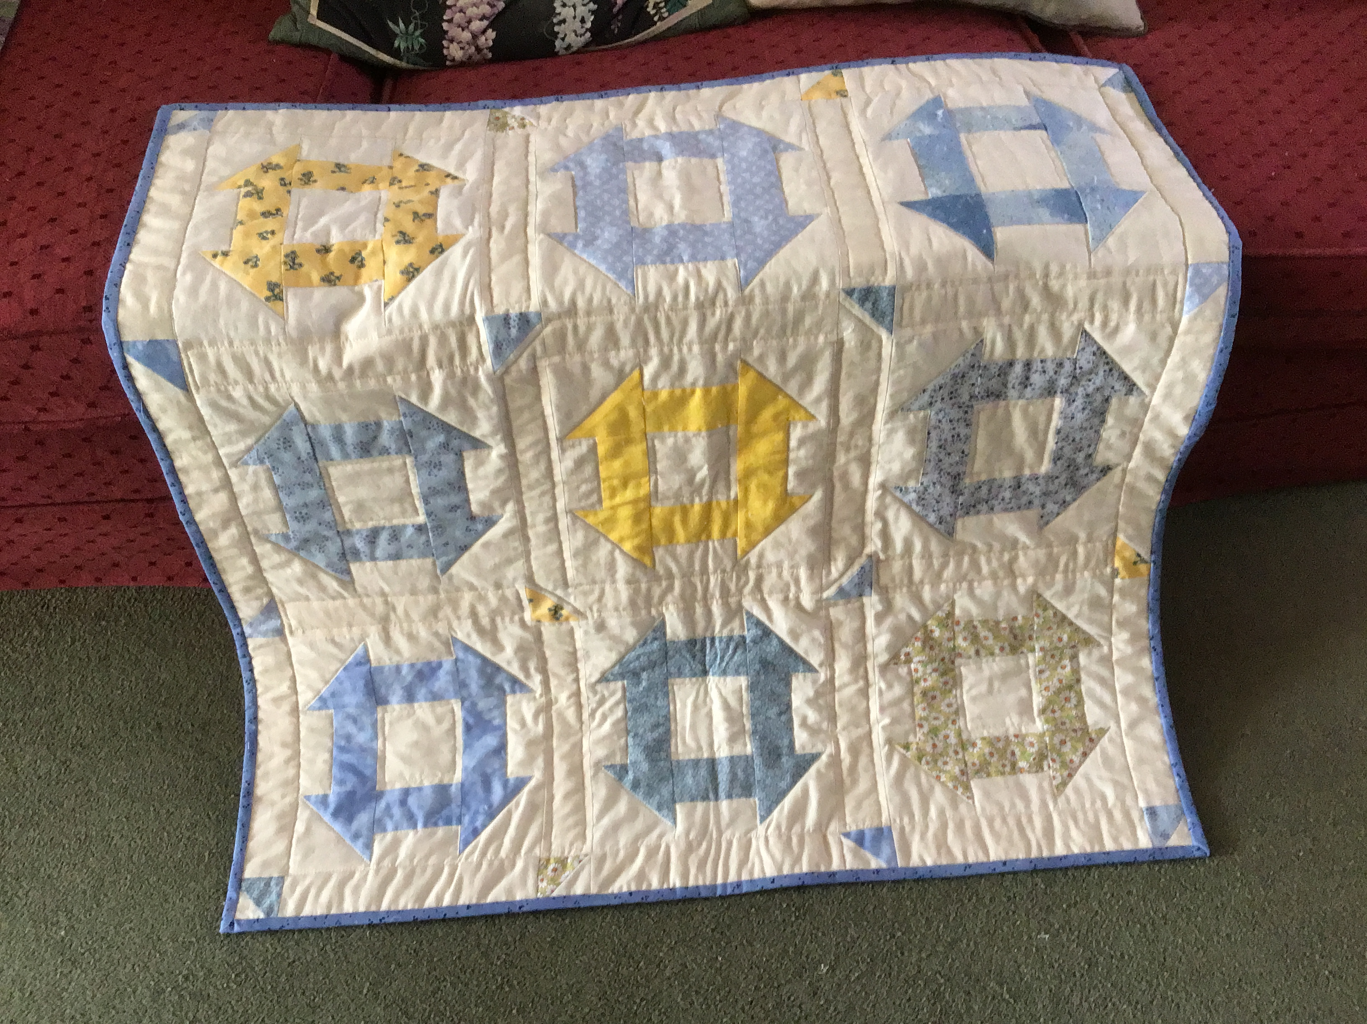

Jennifer Shields has been busy putting together this quilt from blocks she won in a Block of the Month. She wonders if anyone remembers them as they were made “quite a long time back”! Good to know there blocks get used eventually!

And last of all….

A gentle reminder to pay your subscription to Mead Quilters if you haven’t already done so. It is now due.

