Mead Quilters’ Newsletter March 2023

Hello Everyone,

I can’t believe that it’s a month already since the last newsletter. The year is racing past already!

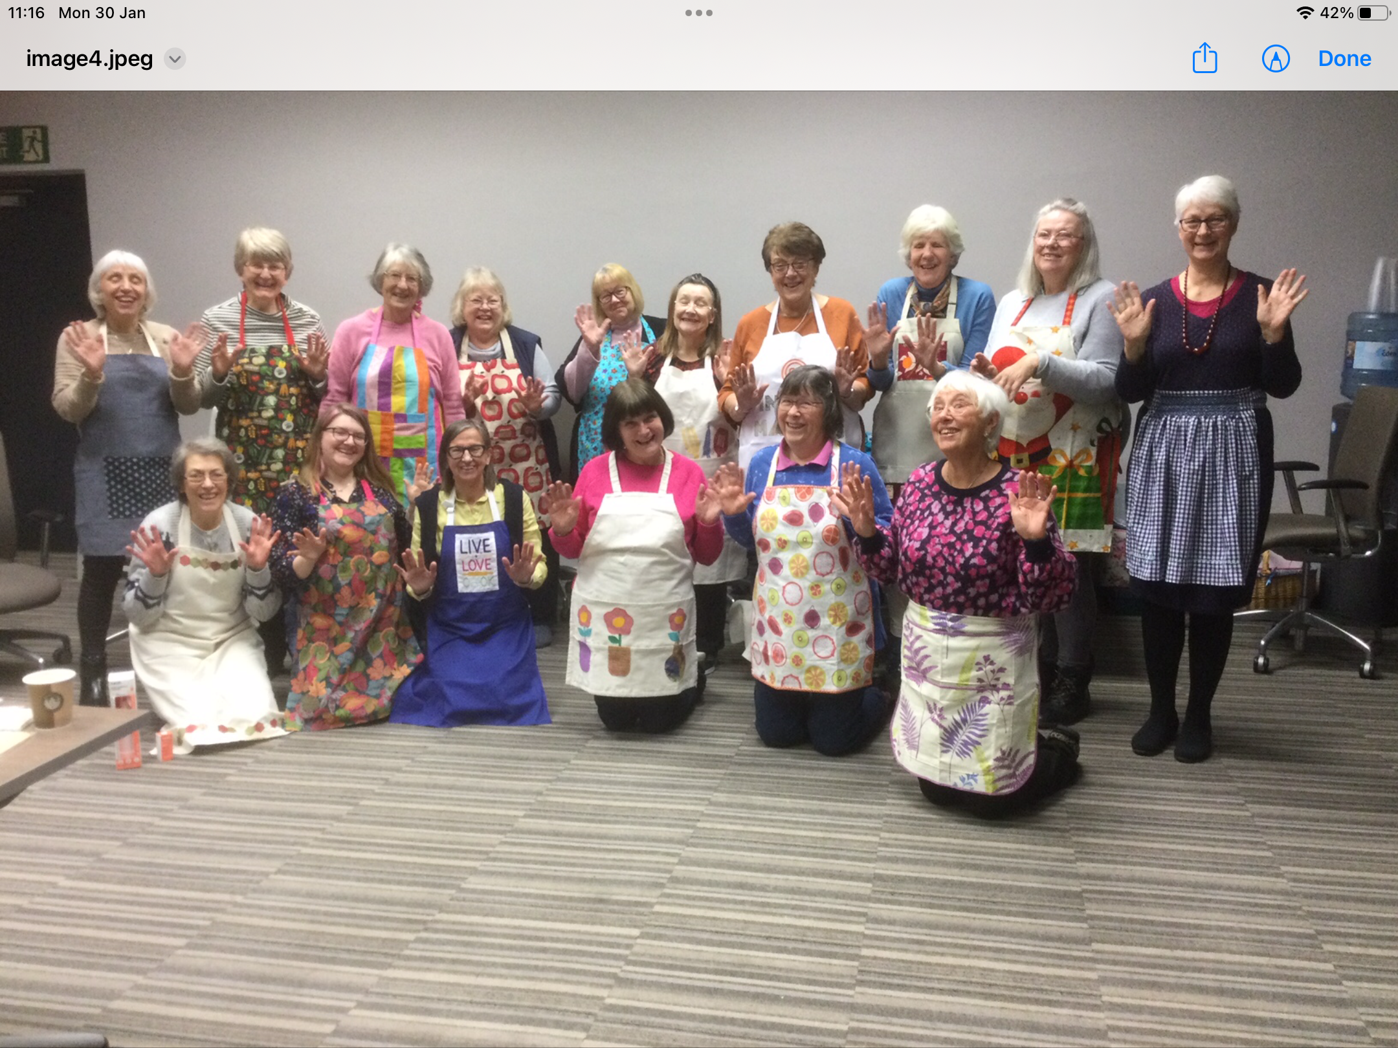
At the end of January 16 keen Mead Quilters and friends assembled at Denham Grove Hotel for a weekend of sewing, laughter and eating.
Here we are modelling our aprons which was the challenge make this year . It’s like a Secret Santa as we don’t know who made the one we won.

A couple of weeks ago the two Alisons had an outing to the Fashion and Textile Museum in Bermondsey to the Kaffe Fassett exhibition “The Power of Pattern”
Here is Alison Williams’ account of the display which she says she found very inspirational.

If you get the chance before it closes on 12 March, do visit the exhibition currently showing at the Fashion and Textile Museum in Bermondsey (near

London Bridge Station). It is called “The Power of Pattern”, and features work inspired by Kaffe Fassett.

A lot of us will probably have used fabric designed by Kaffe somewhere in our sewing lives. He is famous for his use of colour, and the exhibition is certainly colourful! Most of the exhibits are quilts, but there are also some garments and an attractive display of needlepoint cushions using his designs. The quilts are mostly designed and made, not by Kaffe himself, but by quilters and artists using his fabric; there are some famous names among them, including Kathy Doughty from Australia, Victoria Findlay Wolfe from the US, and Danny Amazonas, who I think is originally from Brazil and who had his own display of work at the Festival of Quilts last year.

The F&T Museum is a lovely space for showing these quilts - it is on two levels, and not too big. There is also a space at the end of the exhibition showing some of Kaffe’s original artwork for his designs, plus a slideshow with photos of the actual fabrics. It was illuminating to see just how many of those there have been! As many of you will know, Kaffe himself is celebrating his 85th birthday this year, and he is still bringing out new fabric collections and new books. He gives his name to a Collective, formed of himself, Brandon Mably and Philip Jacobs, and they all produce their own designs for Freespirit fabrics.

It was a “grand day out”, with plenty of places close by to eat or have a coffee, and walks along the river are only a short distance away if you feel like stretching your legs. By the way, rumour has it that the actor James Norton was buying coffee in one of the local cafes…….

The project to make 200 cushions for breast cancer patients at our local hospitals concluded on 21st February with a visit from St Albans MP Daisy Cooper. She took a great deal of interest in all our charitable projects and made a point of talking to everyone present. She was accompanied by her communications manager and there is a press release on her website.
This was a tremendously effort by all involved - in fact more than 300 cushions were made!
I wonder what Heather’s next bright idea will be !

https://daisycooper.org.uk/

THE MEMORIAL HALL in Wheathampstead is open for business again.
It’s looking splendid with a much enlarged kitchen , a separate coffee bar in the entrance , a new meeting room where the library used to be and much improved access.
An open day last week gave local groups including us, the opportunity to showcase their activities. Heather and Carol put up a very colourful display which was complimented by several members of the public.

DATES DATES DATES DATES DATES DATES DATES

7th March. Sewing morning 9.30 am

21st March Evening meeting .
Speaker Penny Bicknell 7.30 pm

http://www.pennyquilts.co.uk/

3rd - 5th March. The Spring Quilt Festival Duxford

23rd - 26th March The Stitch Festival, The Business Design Centre London https://www.thestitchfestival.co.uk

A list of other events in our area can be found at

https://www.quiltersguild.org.uk/regions/region-seven/events

And finally, I have a pair of glasses in a grey case with owls on . They were left behind at the February sewing morning. Do contact me if they are yours.

