Mead Quilters’ Newsletter May 2023.

Welcome to another newsletter. I can’t believe how quickly the months go by and it’s time to put pen to paper, or at least finger to keyboard yet again!

Recently Ginny Edwards organised a photoshoot at St Albans hospital for a formal handover of some of the cushions we have been making for the breast care unit. Thank you Ginny.

Super stitchin’ for West Herts patients
/ Raise News / By Natalie Halliwell-Jennings
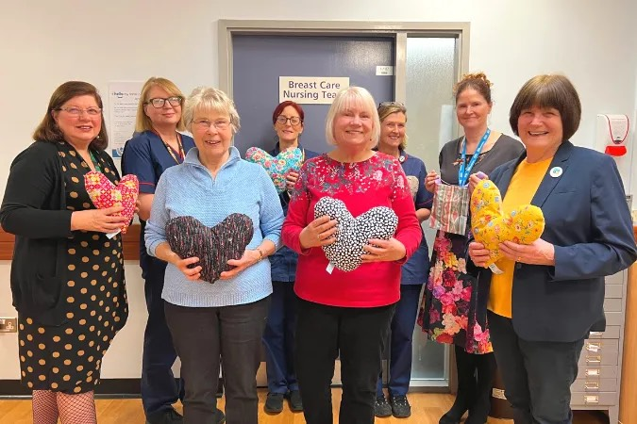/>
Pictured from left to right are: non-executive director and quilter Ginny Edwards, breast & gynae team leader Nathalie Lewis, quilter Carol Wort, clinical nurse specialist Sian Lewis, quilter Linda Cosgrove, clinical nurse specialist Sarah Page, chief nurse Tracey Carter and quilter Jennie Barwise.
A friendly quilt guild based in Wheathampstead, has been busy sewing up a storm to create beautiful little cushions for the breast clinic at St Albans City Hospital.
Over 200 of these little cushions are given out to patients at the breast clinic every year, and are used under the arm for comfort following surgery and placed under a seat belt to protect the surgical area.
The Mead Quilters are a group of sewing enthusiasts who have been meeting and sewing for more than 30 years. The group have been making the little cushions for the breast clinic at St Albans City Hospital for the last six years after two of their members were diagnosed with cancer. In February the quilting group held a ‘cushion-a-thon’ and made over 300 cushions for the breast clinic. The industrious group also makes little bags to hold syringe drivers, primarily for palliative care patients at West Herts, to contain the medication that they can’t take orally.
West Hertfordshire Teaching Hospitals NHS Trust chief nurse Tracey Carter (pictured above second right), and the breast care nursing team met with members from Mead Quilters to receive the cushions and say thank you for their incredible efforts.
“We are so grateful to the Mead Quilters who make the cushions and syringe driver bags for our patients. These will help patients at our hospitals during a difficult time. We’d like to thank everyone at Mead Quilters for their ongoing support and kindness.”
Thank you so much for your kindness Mead Quilters, you’re
ab-sew lutely amazing! 💙
Tracey Carter, chief nurse, West Hertfordshire Teaching Hospitals NHS Trust

From next week there is an interesting exhibition at St Albans Cathedral.

‘Threads through Creation’ is an astonishing textile art exhibition touring 20 English cathedrals. It’s showing at St Albans Cathedral from 3rd May to 11th June.
=
You may have seen it featured in The Quilter. Stitch Magazine and Embroidery Guild publications. It consists of twelve HUGE quilted silk panels (2.7m high, up to nearly 4m wide) re-imagining the creation story from the bible. You’ll find the extraordinary scale, vibrant colours, complex designs and spectacular stitching truly breath-taking.
=
It’s one of the largest textile art projects by a single artist, ever. Jacqui Parkinson spent three years on the panels, using enough material to cover two badminton courts, miles of thread - and eight million stitches! It’s beautiful, highly enjoyable -and anyone who stitches will find it fascinating. Fun for children too. Admission free / donations welcome.
=
See more at www.creation-threads.co.uk and www.stalbanscathedral.org , and more images on Facebook and Instagram – search threadsthroughcreation

I’m attaching a 2 page pdf about the exhibition.

FREE PDF Whether members can get to see the exhibition or not, they can enjoy a free PDF: ‘Behind the scenes’ has 20 pages about Jacqui’s unusual methods, especially interesting for quilters and stitchers. To get it, just visit www.creation-threads.co.uk & click the download button at the bottom of the page.

With thanks and best wishes Andrew Parkinson

DATES DATES DATES.

2nd May. 9.30 am Sewing Morning If you are taking part in the Blue and White block swap we’d love to see your tops.

16th May. 7.30 pm. Our speaker is Anne Kelly

https://annekellytextiles.com/

20th May 1pm -4pm Saturday Sewing

6th June. 9.30 am Sewing Morning

20th June 7.30 pm AGM followed by our Summer Party. The Challenge “Traveller’s Joy
will be judged this evening.

1st July Big Fabric Sale at the Mead Hall. Details to follow.

14th October MEAD SHOW at the Memorial Hall.
If you are making a cushion for the raffle please will you insert a cushion pad. They are available very cheaply from Dunelm.

Alternatively, if you would like to make your own cushion pad , Heather is able to supply the filling and will have some at the next meeting.

Other Events.

5th - 7th May Living Crafts at Hatfield House

13th May Mimram Quilters’ Exhibition

https://mimramquilters.com/exhibition

Royal Academy . The current exhibition “Souls Grown Deep like a River” contains some Gee’s Bend Quilts.

https://www.royalacademy.org.uk/exhibition/souls-grown-deep

Japan House on Kensington High St. has what sounds to be an interesting exhibition showcasing braid making - Kumihimo.

https://www.japanhouselondon.uk/whats-on/2023/kumihimo-japanese-silk-braiding-by-domyo/

A reminder that our regular meetings are on the first Tuesday of the month from 9.30 am
and the third Tuesday of the month at 7.30 pm

