Mead Newsletter September 2023
﻿
﻿﻿﻿Welcome to the September Newsletter.
There’s lots to report this month.

NEWS FROM FESTIVAL OF QUILTS

First of all huge congratulations to our star quilter and sales table organiser extraordinaire Elizabeth Richardson. Together with the great friend of Mead Quilters Mary Mayne she won first prize in the Two Person category at the Festival of Quilts with their quilt “Baltimore Variations “.
We are thrilled for you both.
From photos posted online I can see that our group quilt “Home Sweet Home” looked splendid. Just a shame it didn’t win an award.
Two local quilters and former members of Mead also won prizes. For her quilt “Sunbeams Dance in Grandmother’s Garden” Angela Madden won 3rd prize in the Contemporary Quilt section and John J Madden also won 3rd in the Sustainable category for “Worthless”.
Janet Goddard had her Temperature Quilt hanging at the show as did Teresa Dunn with “Stitched Sketched and Salvaged”.
All the quilts can be seen on the Festival of Quilts website thefestivalofquilts.co.uk.

On a much sadder note, Elizabeth attended the funeral of Sheila Neate and wrote this for us. Thank you, Elizabeth.
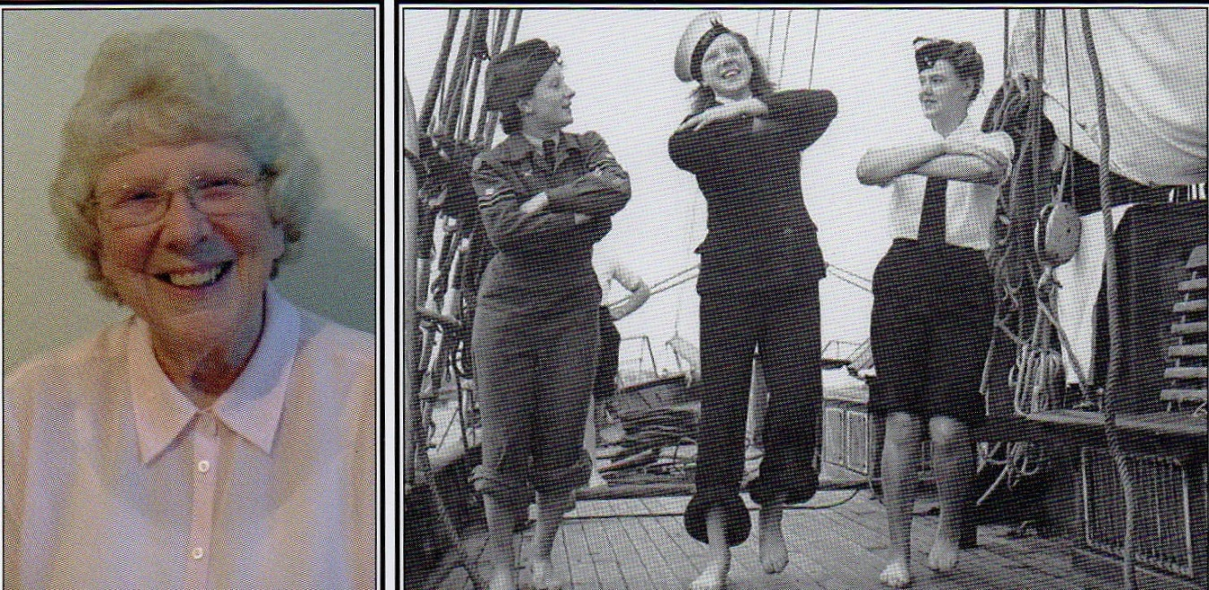
Sheila’s funeral was held on her 70th wedding anniversary on August 1st, 2023. at Beirton Crematorium.

The sun was shining, and her funeral was well attended, it was a lovely service.
One of Sheila’s beautifully made blue quilts (her favourite colour) covered her coffin, and this was topped with carefully chosen flower arrangements from the family.
In the eulogy there were some special reflections about Sheila which were very interesting, her sense of humour was mentioned, her amazing dexterity in baking and quilting and her attention to detail in everything she did.
Clearly Sheila was very much loved.
We were invited to reflect on our memories of Sheila whilst listening to the music of ‘Somewhere Over the Rainbow.’ then this was followed by the hymn, ‘Eternal Father, Strong To Save,.’ which was chosen by the family to remember Sheila’s time serving as a Wren in the navy prior to getting married. (I had no idea she had such an interesting and active life)
We left feeling all the better for having had the privilege of knowing Sheila and having had experience of her kindness and her sense of fun.
(All donations to the Alzheimer’s Society.)
Elizabeth Richardson.

UPDATE ON THE SHOW.
You should all have had the pack of detail put together by the show committee so don’t forget to fill and return your entry forms. If you have cushions for the raffle, please will you bring them with you, if possible, to the meeting on 5th September.

SEPTEMBER MEETINGS - a message from Heather
At the morning meeting in September, we will be making the decorations for the Christmas tree festival. (5th September - ed.) It’s paper pieced so anyone wanting to join in will need hand sewing kit, with white or very pale grey thread. The theme this year is "Silver" as it's the Church's 25th anniversary and the fabrics reflect that. A kit will be provided.

At the Saturday meeting we will be making a different decoration, which is machine stitched. It's a silver Pear pincushion. All material will be provided but we will need a couple of people to bring their machines. Sewing kits will be needed. (16th Sept. 1pm - 4pm. ed.)

19th September 7.30 pm. Talk by Sarah Humphreys aka Edward and the White Bear. You can find her on Instagram and also an interview with her on the Quilters Guild website. quiltersguild.org.uk

Hope to see as many of you as can make it on 5th September!

