﻿Mead Quilters Newsletter: November 2023

Good morning, Everyone. The newsletter a little early this month to give you time to plan for all our upcoming activities!

This coming Tuesday our speaker will be Mary McIntosh, a textile artist from Suffolk.
Read about her at https://www.marymcintosh.co.uk/
7.30 pm as usual.

Christmas Activities.
Here is what is planned for our December meetings. 5th December morning and 19th December evening.
December morning meeting
Social sewing morning with mince pies and coffee.
There will be a Christmas show and tell. Bring your Christmas quilts along to share with the group.
Jennie Barwise will demonstrate making folding boxes that can be used for small Christmas gifts. Please bring a pencil, ruler and paper scissors if you would like to join in. Otherwise bring your sewing as normal.

December Evening Meeting – Christmas party
All members are welcome to attend. Please bring a plate of food, as usual 6 items of sweet or savoury food to share. We will serve drinks. The evening entertainmant will be a quiz organised by Jennie.
Please bring a wrapped gift to the value of £5 for the bran tub.Everyone will receive a raffle ticket on arrival and be able to choose a surprise gift from the tub.

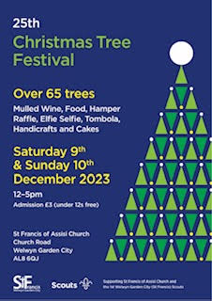

Christmas Tree festival
The Christmas tree festival will be held at St Francis Church in WGC. Our tree will be on display, along with many others. Do pop along to support the church.

We hope you will be able to join us for at least one meeting and if you can’t make your usual morning or evening session then you will be very welcome at the other one.

Don’t forget to visit the Christmas Tree Festival where all those stars and pears you made will be on display

A little advance notice for the New Year.
As well as the usual morning and evening meetings (1st and 3rd Tuesdays as usual)
on 8th January there will be a Zoom meeting with other groups which will be a talk given by Diana Boston about the Patchwork of the Crosses, made by her mother-in-law Lucy Boston. There is plenty to read if you do a Google search. Details to follow.
Hope to see you at these events.
Happy Quilting

