February 2024
Welcome to the latest newsletter.

CONGRATULATIONS to Mead member Janet Goddard. Her book “Denim Upcycled” has been short listed in the Best Upcycling Book category for the Creative Book Awards 2024. Fingers crossed for you Janet on the 19th February when the results are announced.

At the beginning of the month Diana Boston gave a very interesting presentation about the quilts of her mother-in-law Lucy. What struck me was how cleverly she used her fabrics, especially stripy ones, to great effect with very careful placement.
The “Bring a Gadget” evening was enjoyed by everyone there and provoked lots of discussion particularly about needle threaders!

Charity Quilts
Watford General Hospital welcomes nearly 60 festive babies.
Nearly 60 families in west Hertfordshire received the best gift ever as they welcomed in their festive new arrivals over Christmas and New Year.

To celebrate the special occasion, Mitra Bakhtiari, director of midwifery, was joined by non-executive director Ginny Edwards on Tuesday 2 January for a walkaround on the maternity wards, visiting the families who had welcomed their babies over the New Year. During their visit, Ginny and Mitra presented gifts to the families and their babies, which were kindly donated by West Herts Hospitals Charity.

Ginny also presented some handmade quilts to the families, which were thoughtfully crafted and gifted by the Mead Quilting Group and other local quilters in west Hertfordshire.
Ginny Edwards said “I am so pleased that we were able to visit families during what is a very special time for them. It was so wonderful to meet with some of the new parents on the maternity unit and see our hard-working staff in action.”

“We are also so grateful to the talented quilting groups who spent their time lovingly creating quilts for the families of our newborn babies. Thank you to all the staff who have worked over the festive period to help deliver our babies.”

Ginny Edwards has provided these photos (which are shown here with permission) of New Year babies at Watford Hospital receiving some of our quilts.
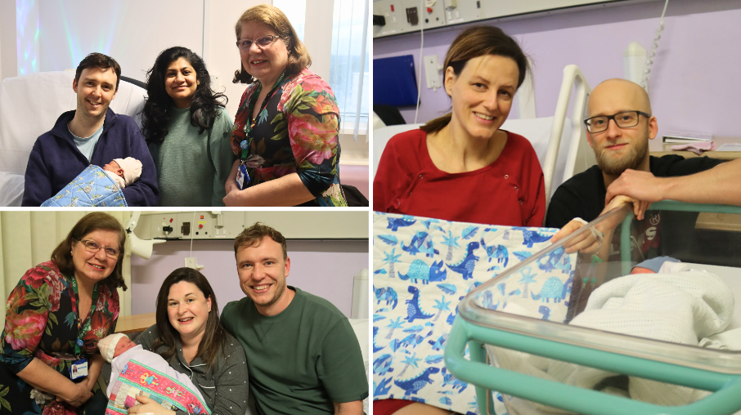
Pictured above are 3 families whose babies were born around New Year with Ginny Edwards. Baby boy Ciesla rung in the New Year for his Watford based family at 9.35pm. He was shortly followed by baby girl Musson at 11.20pm, whose family are from Rickmansworth. Baby girl Bartram was born the next day on Tuesday 2 January to delighted parents from Watford.

Ginny is also happy to take blocks that you have but never found a place for in a quilt. They will be donated to the charity Quilts for Care Leavers: q4cl.org.uk where they will be made into “quilty hugs” for young people.

DATES. DATES. DATES
February 6th 9.30 am and February 20th 7.30pm
We have quite a few new members in Mead Quilters, so it seemed like a good idea to resume wearing name badges. Both February meetings will be devoted to making a badge although some of you will still have your original, I’m sure.

Heather has provided a kit list.
Sewing kit
Fabric scraps
Piece of felt
Scrap yo-yos, hexagons, small motifs, buttons, tiny trims etc
Embroidery thread
Safety pin or lanyard

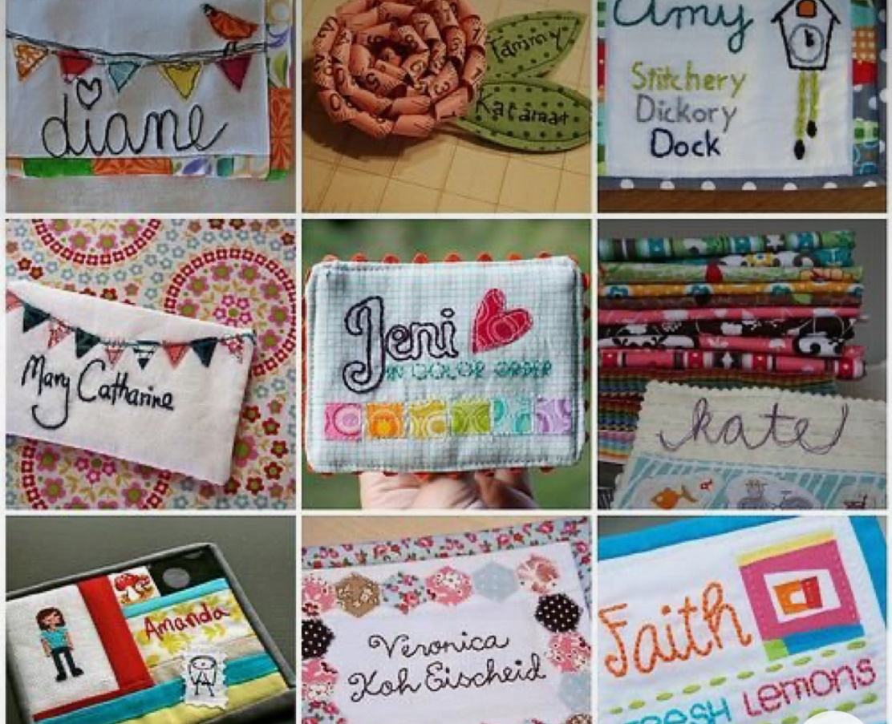

Here are some examples to inspire you !

We also have a speaker this month but unusually at the Saturday Sewing Meeting, 1pm on 17th February. It will be Maria Thomas who makes quilts, garments and smaller pieces all heavily embellished. mariathomastextiles.co.uk

Living Crafts
The committee has decided that we will have a stand at Living Crafts this year which takes place from the 9th to the 12th of May. This helps to promote our craft and Mead Quilters.
In order to make a success of this we will be asking for you to volunteer to spend a few hours there on one of the days. Put the dates in your diary!

