APRIL 2024 . Welcome to the latest news from Mead Quilters.

IMPORTANT

In this newsletter you will find the form with which to renew your membership of Mead Quilters for 2024 - 2025. Please print this form and return it as instructed. If you are not able to print it there will be some paper copies at our meetings.

RED HOUSE QUILT KIT.
You may remember that Elizabeth was raffling a quilt kit for The Quilters Guild Red House quilt.
The lucky winner was Linda Cosgrove. We hope you enjoy making it Linda.

New Horizons Textile Group
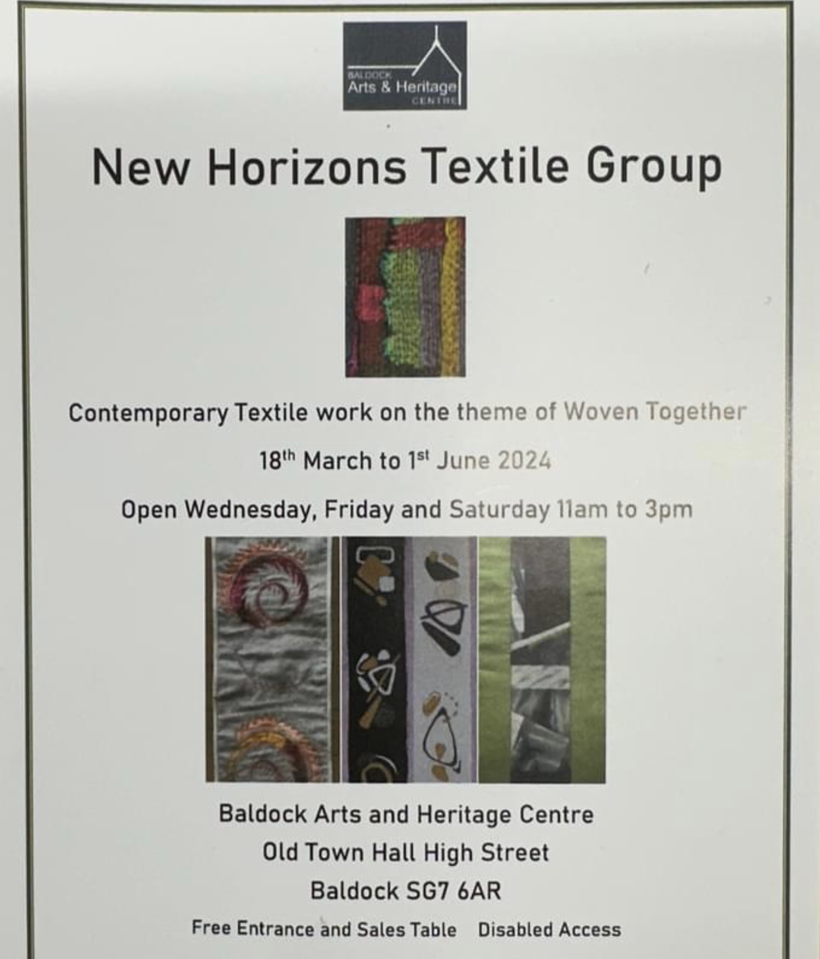
Mead memberTeresa Dunn is participating in this show which is open now until 1st June in Baldock. More information about their work on their website.

https://www.newhorizonstextilegroup.com/

OTHER DATES FOR YOUR DIARY

APRIL 2nd Morning meeting 9.30 am.
APRIL 16th Evening meeting 7.30 pm.
Unfortunately our April speaker has had to withdraw but Barbie Edwards has kindly agreed to run a fabric wreath making workshop.
Details to follow

Ginny and her projects!

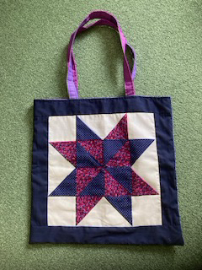
Thank you to all of you who have been supporting my projects. I really appreciate it. I was gifted some blocks from Sheila Neate’s stash, which I am turning into quilts but this was an orphan block, so I put a blue border on it and turned it into a tote bag to hold a quilt. My big project this year is to make quilt hugs (min 40 x 60inches) for the 40 or so 16/17 year old young adults in Hertfordshire who are homeless and in hostels, in time for Xmas. If any of you fancy making a tote bag to donate to my collection all gratefully received, along with quilts or an offer to quilt tops already made, wadding and backing supplied.

Thanks again for all your support. I really appreciate it.
Ginny

Thank you Ginny for all that you do to support so many charities.

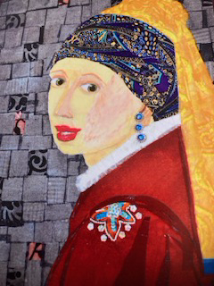
Ginny also recently heard Dr Aruna Meme speak about her fabric collages and other items made from recycled materials. There is to be an exhibition of her work in May . Details below.

https://harrowarts.com/whats-on/event/joy-vibrant-happy-fabric-collages

Exhibition in Cambridge
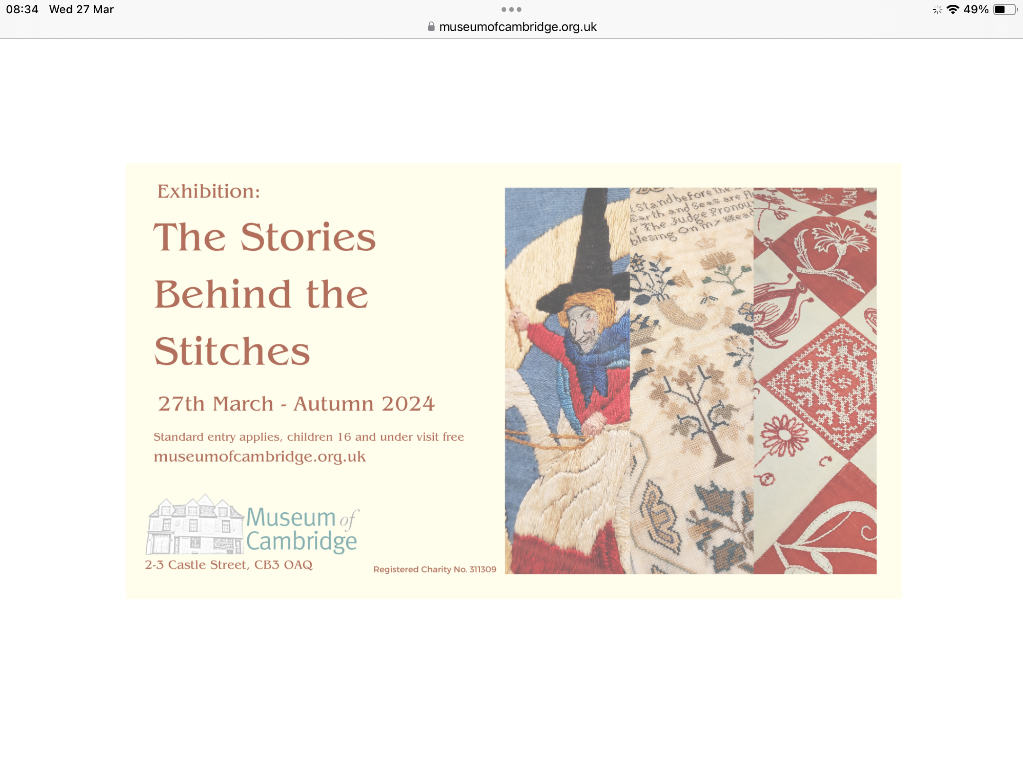
MEAD QUILTERS RENEWAL FORM 2024 – 2025

The committee has decided to use the some of the profit from the 2023 Mead Quilt Show to subsidise the subscription this year by £10 for ALL members. The fee for full members will be £35 and for morning only members £17 for the year. Associate membership stays at £10. New members will pay the full subscription of £45 or £27 ( morning only).
To renew your subscription for the period May 2024 to April 2025 please complete the form below in full and place in a named sealed envelope with the appropriate fee if paying by cash or cheque.
You may also pay by bank transfer and email the form to Carol Wort - details below.

Mrs/Miss/Ms/Mr/Other
NAME ……………………………………………………
ADDRESS ………………………………………………………
.…………………………………………………………………...
POST CODE ……………………
TELEPHONE ……………………………………..
MOBILE ………………………………………
EMAIL ………………………………………….

If you do not want your photo to appear in any Mead literature including online, please TICK THIS BOX [ ]

Please tick the relevant box.
- Full Membership £35 (new members £45 ) [ ]
- Morning only membership £17 (new members £27) [ ]

Please tick how you would like to pay
[ ] Bank Transfer
Bank HSBC
Account Name:- Mead Quilters
Account Number:-91224107
Sort Code:- 40-23-11

IMPORTANT. PLEASE ADD YOUR OWN NAME AS REFERENCE

[ ] Cheque:- made payable to “Mead Quilters”

[ ] Cash

All subscriptions to be paid by Wednesday 17th April 2024 please.

Please return your form together with any cash or cheques to Carol Wort or Alison Williams at the Mead Meetings or to Carol at 330 Lower Luton Road, Wheathampstead, St Albans AL4 8JQ.

Or complete the form online and email to Carol - c.wort48@gmail.com

